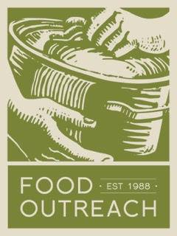
Statement of Commitment
Estate Provisions
Food Outreach asks that you provide the following information and attach any documents that further describe the nature of your non-contingent estate arrangements for the future benefit of Food Outreach. All gifts and bequests for the benefit of Food Outreach should be made to Food Outreach.
Name(s) of Donor(s):
Document Type: Will Living Trust IRA Charitable Remainder Trust
Other (please specify)
If married, will your estate gift be distributed upon the death of the first or both spouses?
Please provide you and your spouses’ Dates of Birth: (1) (2)
Will your estate gift be distributed upon the death of any additional persons (siblings, child, etc.)?
Please provide Name, Relationship to you, and Date of Birth for each person:
Name: Relationship: Date of Birth:
Name: Relationship: Date of Birth:
Name: Relationship: Date of Birth:
Please tell us the nature of your gift:
Dollar Amount: $ or Percentage: %
Based on the current value of your commitment,
Please estimate the gift for Food Outreach:
Is this commitment to be restricted? If yes, please specify.

For gift crediting purposes, I (we) understand that I (we) should notify Food Outreach if changes are made to my (our) estate plan(s) that will affect the above provisions. It is understood that all bequests are revocable and any bequest intentions stated herein are not binding upon my (our) estate(s).

Donor Signature Date

Donor Signature Date

